How to create a Federal amended return and get to the Federal screen for entering Original (Column A) amounts
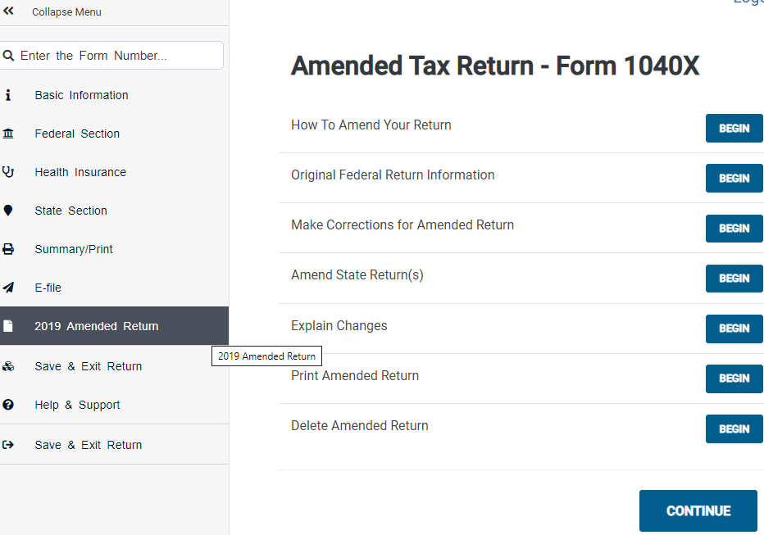
Step 2 – Click “Original Federal Return Information”
The button will read “BEGIN” before the Federal amended return is created; it will read “EDIT” if there already is a Federal amended return
Step 1 – Click on the Amended Return Menu item

The following pages show the screen where you enter information for the original Federal return. There is only one (long) screen.
Beside each box is the information you can get by clicking on the “Where is this location?” link.
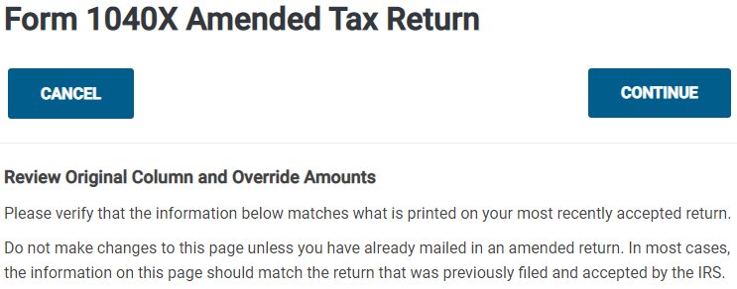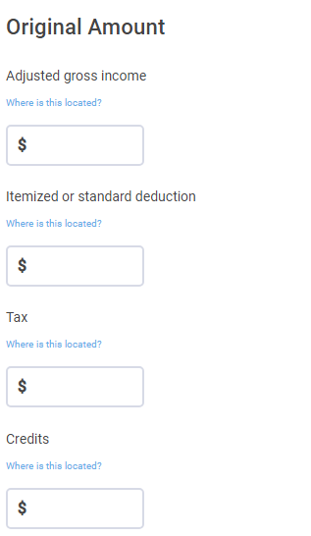
If you filed a Form 1040: Line 13a and Schedule 3, Part 1, Lines 1-6
If you filed a Form 1040X: Line 7
If you filed a Form 1040: Line 12b
If you filed a Form 1040X: Line 6
If you filed a Form 1040: Line 9
If you filed a Form 1040X: Line 2
If you filed a Form 1040: Line 8b
If you filed a Form 1040X: Line 1
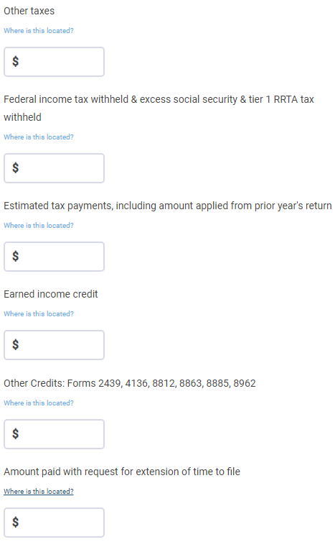
If you filed a Form 1040: Schedule 3, Part 2, Line 10
If you filed a Form 1040X: Line 16
If you filed a Form 1040: Line 18b and 18c; Schedule 3, Part 2, Line 9, 12, 13
If you filed a Form 1040X: Line 15
If you filed a Form 1040: Line 18a
If you filed a Form 1040X: Line 14
If you filed a Form 1040: Schedule 3, Part 2, Line 8
If you filed a Form 1040X: Line 13
If you filed a Form 1040: Line 17 and Schedule 3, Part 2, Line 11
If you filed a Form 1040X: Line 12
If you filed a Form 1040: Line 15 and Schedule 2, Part 2, Lines 4-9
If you filed a Form 1040X: Line 10
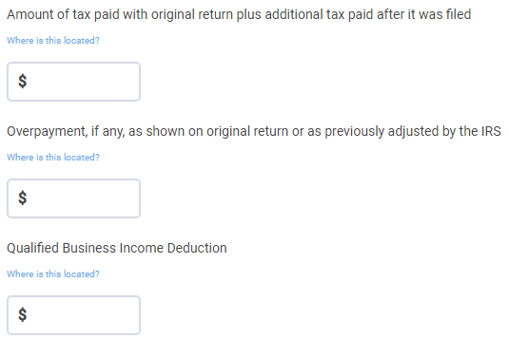
If you filed a Form 1040: Line 10
If you filed a Form 1040X: Line 4b
If you filed a Form 1040: Line 20
If you filed a Form 1040X: Line 18
If you filed a Form 1040: Line 23
If you filed a Form 1040X: Line 16
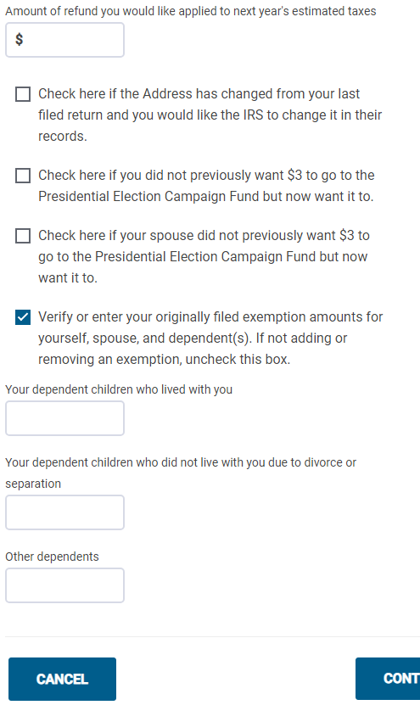
Be sure to check or uncheck each of the checkboxes here appropriately.

How to get to the Federal screen for entering Explanation
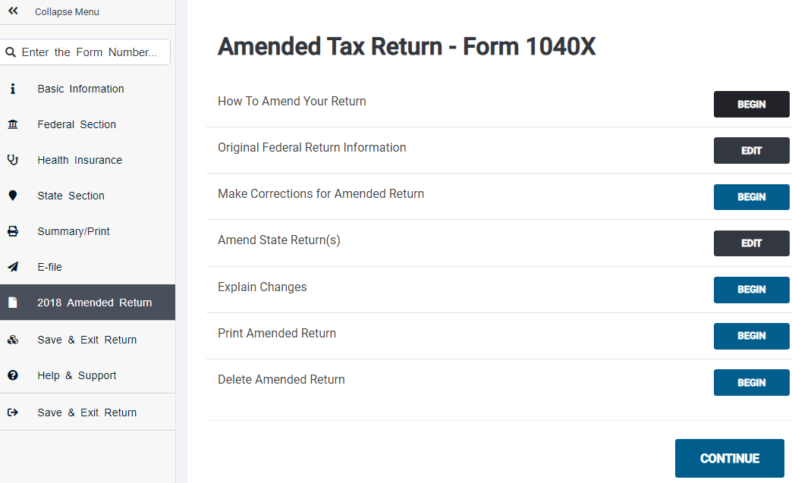
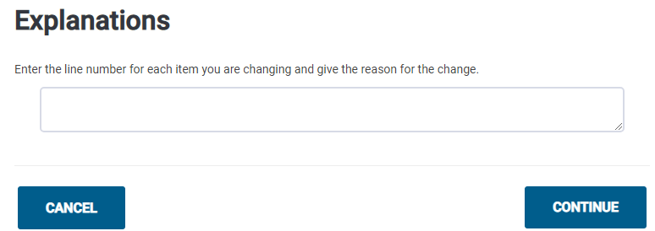
From 1040X Instructions:
The IRS needs to know why you are filing Form 1040X. For example, you:
- Received another Form W-2 after you filed your return,
- Forgot to claim the child tax credit,
- Changed your filing status from qualifying widow(er) to head of household, or
- Are carrying an unused NOL or credit to an earlier year,
- Are claiming a tax benefit from recently enacted legislation for
- disaster relief.

How to delete a Federal amended return

There is no separate screen – the Federal amended return is deleted, and you are returned to the main Summary/Print screen
Note: Only the Federal amended return is deleted. The NJ amended return is not affected.

How to print a Federal (and NJ) amended return

You are taken to the following screen. When you click “CONTINUE” you seem to go the same screen for viewing the return as you ordinarily get from the Summary/Print screen.
Note: The printed return will contain both Federal and NJ returns
Note: The returns seems to be the same as what you would get from Summary/Print screen
